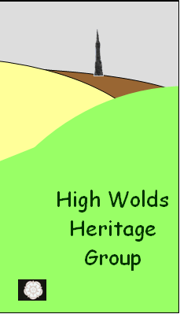
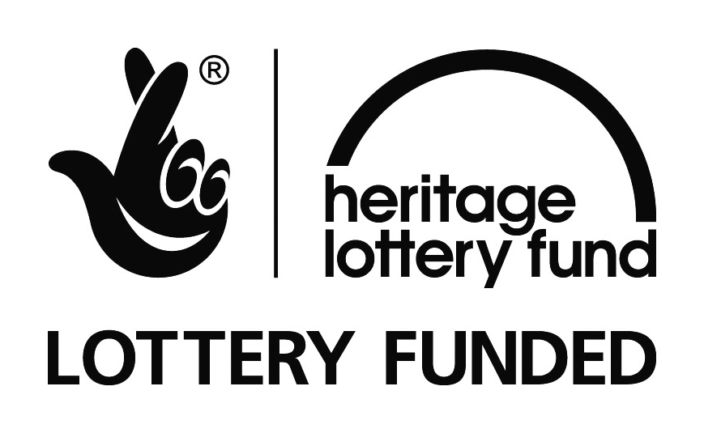
Exploring Acklam
A guided walk with Keith Holtby
July 28th 2011

12 people enjoyed the talk given by Tony Wilson. They then explored the museum dedicated to the Wagoners Special Reserve.
The Wagoners' Special Reserve was the brainchild of Sir Mark Sykes 6th Baronet of Sledmere. These men became some of the first to go abroad in the First World War, driving the horse-drawn wagons that supplied the frontline.
You can find out more about this interesting small museum at http://www.sledmerehouse.com/wagoners
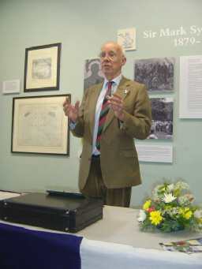
Tony Wilson
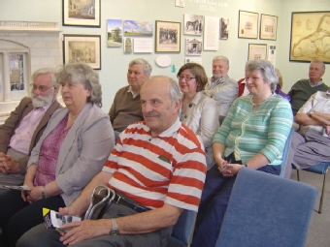

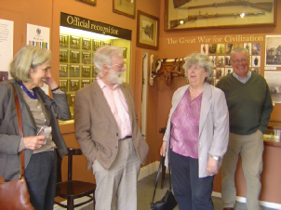
Exploring the museum

